# Report 2

**team members：**

白明松 16301059

**technical features applied：**

Use Case Scenario:

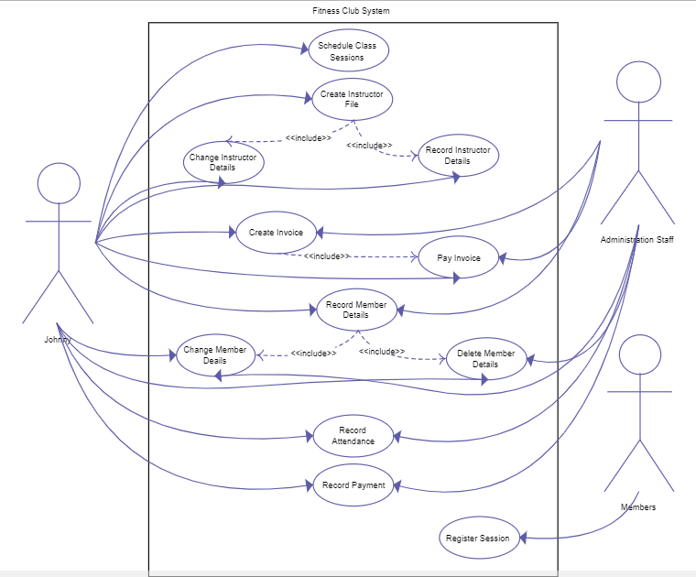

This assignment is to practice the android sdk programming, more specifically development using activities, views, widgets, intent and http access libraries such as retrofit.

RecyclerView and CardView

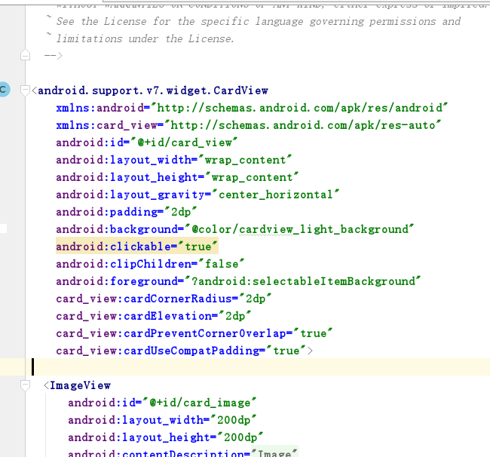

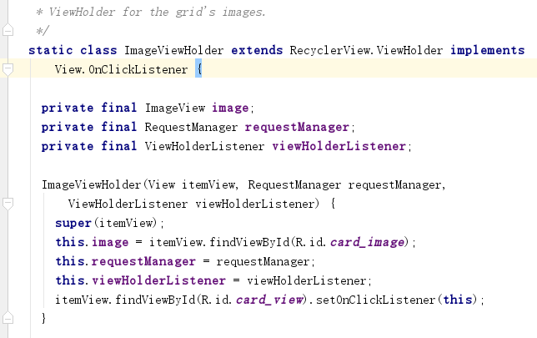

Login

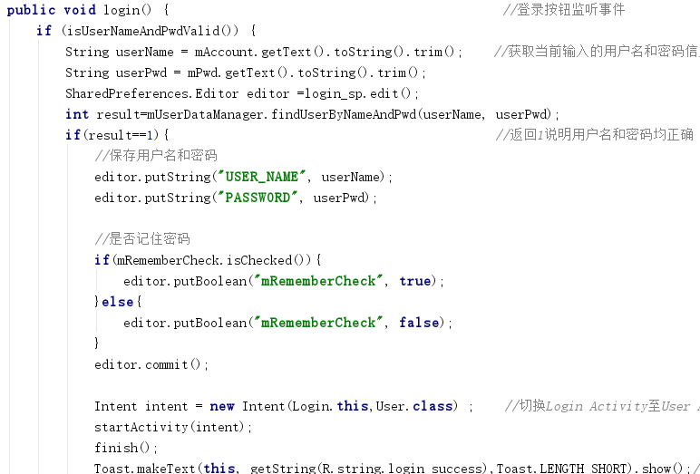

Register

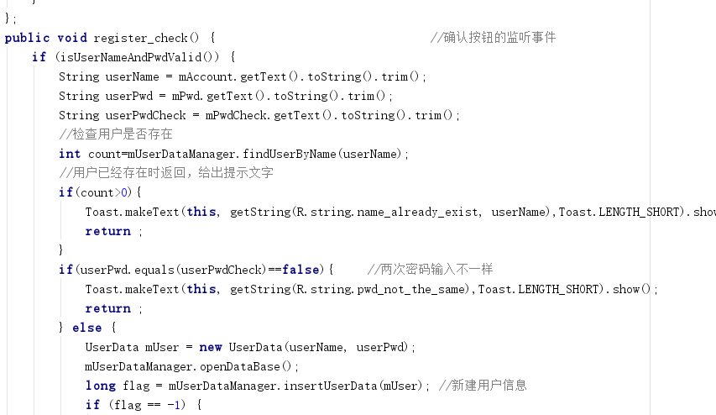

HTTP Request

